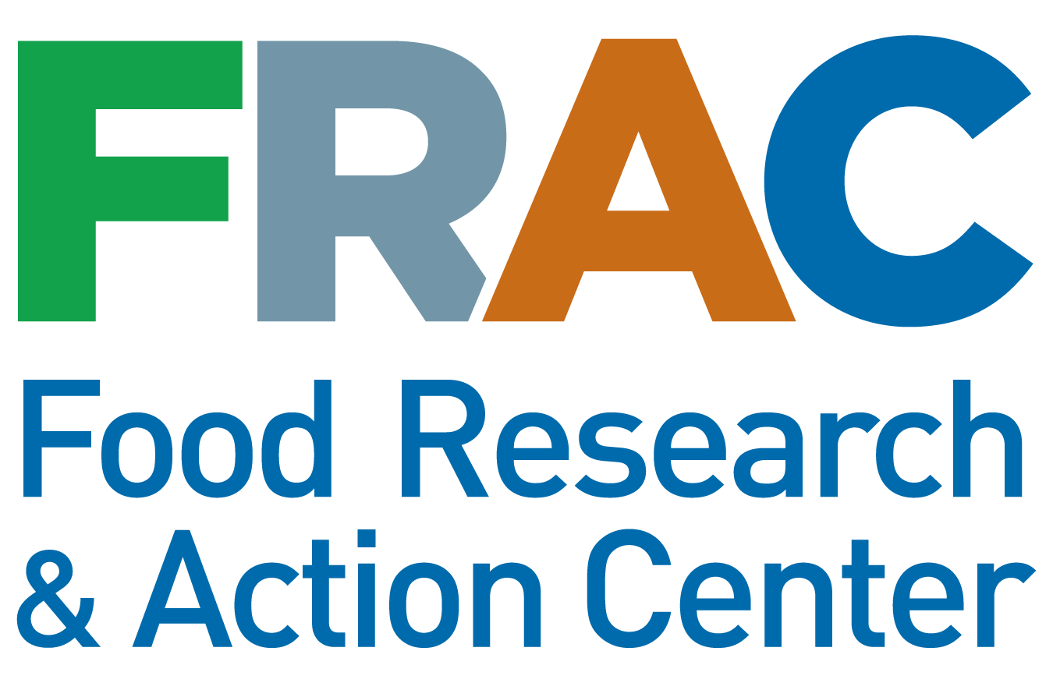
MODEL COMMENT TEMPLATE FOR
ANTI-HUNGER & NUTRITION STAKEHOLDERS

Guidance on creating a unique comment using this model template

To make sure your comments deviate from the below model template by more than 30% so that it is counted by the agency as a unique comment, please:

- Pick 2 or 3 of the following sections from the template below:

  - The proposed Rule would spur immigrants who are legally authorized to participate in SNAP and other programs, including Medicaid, Medicare Part D, and housing assistance, to forgo assistance or disenroll, jeopardizing their food security, health, well-being, and economic security.

  - This Rule will not only impact participation in SNAP but also participation in other vital nutrition programs, rolling back progress in addressing hunger and poverty in this country.

  - The harms of the proposed Rule would amount to a cost shift to states and localities.

  - The Rule will generate confusion among immigrant families, government agencies, schools, social service providers, charitable networks, and advocates as to whether families could receive benefits without putting their or a loved one’s immigration status at risk, and place additional strains on provider networks.

  - The Rule would create upstream and downstream harms to state and local economies, large and small businesses, and individuals.

- Add any information you wish and tailor the highlighted sections of the template, and any other text you desire, with specific state/organizational information.

Submit your comment at frac.org/publiccharge by December 10, 2018

Please use the FRAC microsite so we can track how many anti-hunger groups and stakeholders submitted comments.
Department of Homeland Security
20 Massachusetts Avenue NW
Washington, DC 20529-2140

Re: DHS Docket No. USCIS-2010-0012, RIN 1615-AA22, Comments in Response to Proposed Rulemaking: Inadmissibility on Public Charge Grounds

Dear Sir/Madam:

I am writing on behalf of [insert name of organization] to express strong opposition to the Department of Homeland Security’s proposed Rule “Inadmissibility on Public Charge Grounds” and ask that the Rule be withdrawn. The deeply flawed Rule unravels decades of sound and settled public policy that draws a clear and responsible line between those public benefits which may be used without causing public charge consequences for immigration purposes and those that may not.

[INSERT a paragraph describing your organization, why this is particularly urgent to you, and the expertise that you have on issues raised. If you are a service provider, consider including specific data on the populations you serve. If you are a state/local organization, consider including demographic information.]

For almost two decades, U.S. immigration officials have explicitly reassured, and immigrant families have relied on that reassurance, that participation in programs, like SNAP, would not affect their ability to become lawful permanent residents. The proposed Rule would reverse longstanding existing law, policy, and practice in interpreting the public charge law, where the receipt of non-cash benefits has never been the determining factor in deciding whether an individual is likely to become a public charge. If adopted, the rule would lead to a hungrier, sicker, and poorer nation, and would have the most severe impact on immigrants who are people of color, children, seniors, non-English speakers, and low- or moderate-income earners.

The proposed Rule would spur immigrants who are legally authorized to participate in SNAP and other programs, including Medicaid, Medicare Part D, and housing assistance, to forgo assistance or disenroll, jeopardizing their food security, health, well-being, and economic security. As the Administration acknowledges, public benefits “play a significant role” in the lives of recipients (83 Fed. Reg. 51,163). These programs provide critical support to assist individuals and families to work, to attend school, and to maintain and improve their health. When individuals and families access these vital programs the entire community and country benefits — when they do not, food security, health, education, and economic security suffer.

Pursuant to the Department of Homeland Security’s (DHS) own admission on page 51,270 of the proposed Rule: “Disenrollment or forgoing enrollment in a public benefits program by aliens otherwise eligible for these programs could lead to:
- worse health outcomes, including increased prevalence of obesity and malnutrition, especially for pregnant or breastfeeding women, infants, or children, and reduced prescription adherence;
- increased use of emergency rooms and emergent care as a method of primary health care due to delayed treatment;
- increased prevalence of communicable diseases, including among members of the U.S. citizen population who are not vaccinated;
- increases in uncompensated care in which a treatment or service is not paid for by an insurer or patient;
- increased rates of poverty and housing instability; and
- reduced productivity and educational attainment.”
In the proposed Rule, DHS estimates the number of individuals who are likely to disenroll or forgo enrollment in public benefit programs, including SNAP, at 2.5 percent of the number of recipients who are members of households that include foreign-born, non-citizens. Even though this estimate is based on a deeply flawed analysis, under this conservative scenario, almost 130,000 people — many of them children — would lose access to SNAP.

The outcomes of participation in SNAP — particularly for children — are very positive. As just two examples:

- A raft of studies show that SNAP improves food security, dietary intake, and health, especially among children, and with lasting effects.
- As researchers reported in SNAP Matters: “SNAP [is] the most effective antipoverty program among the non-elderly,” reducing rates of poverty, especially for children, more than do other programs.

For more on the benefits of SNAP, refer to FRAC’s Hunger and Health: The Role of the Supplemental Nutrition Assistance Program in Improving the Health and Well-Being of Americans. http://www.frac.org/research/resource-library/snap-public-health-role-supplemental-nutrition-assistance-program-improving-health-well%e2%80%90being-americans

This Rule will not only impact participation in SNAP but also participation in other vital nutrition programs, rolling back progress in addressing hunger and poverty in this country. A recent study found that immigrant families — including those who are lawfully present — are experiencing resounding levels of fear and uncertainty across all background and locations. (Samantha Artiga, “Living as an Immigrant Family in America: How Fear and Toxic Stress are Affecting Daily Life, Well-Being, & Health.) While public benefit programs, like WIC, and other child nutrition programs are not included in the proposed public charge Rule, the fear, confusion, and caution surrounding the Rule would have a spill-over impact on these programs, resulting in immigrant families forgoing vital nutrition assistance.

Families will choose not to participate or have their children participate due to fear — both real and perceived — that seeking nutrition benefits could result in a loved one being denied a change in immigration status or entry into the U.S. Even before the Rule was published in the Federal Register, eligible immigrants and U.S. citizen children did not apply for or dis-enrolled from programs, like WIC, thereby forgoing vital nutrition based on future fears and uncertainty as to the state of the law. For example, 67 percent of California health care providers participating in a 2018 survey noted an increase in parents’ concerns about enrolling their children in WIC. (See the infographic, “California Children in Immigrant Families: The Health Provider Perspective,” by The Children’s Partnership: https://www.childrenspartnership.org/wp-content/uploads/2018/03/Provider-Survey-Inforgraphic-.pdf.)

For more on the benefits of the Child Nutrition Programs, refer to: Hunger and Health — The Role of the Federal Child Nutrition Programs in Improving Health and Well-Being http://www.frac.org/research/resource-library/hunger-health-role-federal-child-nutrition-programs-improving-health-well

The harms of the proposed Rule would amount to a cost shift to states and localities. States and localities should not have to bear the costs of federal withdrawal of assistance to people who depend on safety net and public benefit programs. When families lose access to all the benefits of programs — like SNAP, WIC, and other child nutrition programs — states, counties, and localities will suffer economic burdens emanating from this federal action. The proposed public charge Rule would cost the state by forcing states to use state and local funds to fill gaps caused by loss of federal funds. When families disenroll from SNAP and other safety net programs out of fear and confusion, their need for supports to help meet basic needs does not disappear. Instead, costs associated with assisting families to meet their basic needs previously paid for with federal funds will be shifted to state and local entities. This will create an unsustainable cost burden and pull state and local funding away from other state programs. In the wake of eliminating SNAP eligibility for many legal immigrants after the 1996 Personal Responsibility and Work Opportunity Reconciliation Act (PRWORA), several states invested state dollars to meet part of the resulting need for food assistance. Those stop-gap measures proved to be neither comprehensive nor sustainable in the long run. Under the proposed Rule, state and local governments would again face costs that would be associated with the loss of federal funds for public benefits, as well as the harms to health, food security, economic security, education, and well-being of families resulting from the loss of public benefits.

The Rule will generate confusion among immigrant families, government agencies, schools, social service providers, charitable networks, and advocates as to whether families could receive benefits without putting their or a loved one’s immigration status at risk, and place additional strains on provider networks. Immigrants will struggle with how to make sense of this complex Rule and how it could jeopardize the immigration status of oneself or a family member. Likewise, service providers — including government agencies, schools, medical providers, safety net hospitals, faith-based organizations, and charitable organizations — that work with immigrant families or administer SNAP and other public benefit programs will be at a loss as to how to interpret the proposed Rule and advise immigrant families.

[insert examples]

Compounding the Rule’s harm, many families may forgo assistance from programs that they can participate in without fear of immigration consequences because of the climate of fear or faulty advice given out of an abundance of caution.

The Rule would create upstream and downstream harms to state and local economies, large and small businesses, and individuals. In the announced rule, the Department of Homeland Security notes how the rule “could have downstream and upstream impacts on state and local economies, large and small businesses, and individuals,” including “retailers participating in SNAP, [and] agricultural producers who grow foods that are eligible for purchase using SNAP benefits” (page 51,118 of the Rule).

The U.S. Department of Agriculture estimates that every $5 in new SNAP benefits generates $9 in economic activity. When needy individuals forgo SNAP assistance, states are stripped of millions of dollars in federal funding that could pay for food to nourish infants, students, seniors, veterans, and working families, and could create jobs in food retail, transportation, and agricultural sectors.

[insert information on how SNAP helps your state]

In conclusion, the combination of decreased participation in SNAP, Medicaid, housing assistance, Medicare Part D Low-Income Subsidy, and other nutrition programs resulting from the Rule would lead to a hungrier, sicker, and poorer nation. The impact of individuals and families foregoing needed support from the programs specifically targeted in the Rule and other federal nutrition programs will be higher rates of food insecurity and hunger.

Food insecurity is associated with some of the most common and costly health problems among adults, including diabetes, heart disease, obesity, hypertension, chronic kidney disease, and depression. The consequences of food insecurity are especially detrimental to the health, development, and well-being of children. Research shows a link between food insecurity and poor educational performance and academic outcomes for children — all of which have developmental, health, and economic consequences in both the short and long terms. (See Food Research & Action Center, The Impact of Poverty, Food Insecurity, and Poor Nutrition on Health and Well-Being (Dec. 2017), available at: http://www.frac.org/wp-content/uploads/hunger-health-impact-poverty-food-insecurity-health-well-being.pdf)

For these reasons, the Department should withdraw its current proposed public charge Rule, and dedicate its efforts to advancing policies that strengthen — rather than undermine — the ability of immigrants to support themselves and their families in the future.

Name
Title
[Insert contact information and add signature line if desired.]

Reminder: Please use frac.org/publiccharge to submit your comment so we can track how many anti-hunger and nutrition groups oppose the rule.

