June Recess:

Tell Congress to Celebrate America’s Birthday by Protecting SNAP

Goal:
- Use our collective voices and networks to urge Congress to protect SNAP (Supplemental Nutrition Assistance Program) during summer budget negotiations by rejecting any cuts or rollbacks.
- Lift up SNAP as a vital, patriotic investment in freedom, dignity, and community.
- Food is freedom, a fundamental right that empowers individuals to pursue life, liberty, and happiness. That true patriotism is found in feeding and uplifting our communities, ensuring that all people have the opportunity to achieve economic mobility and thrive.

Sample Graphics and Posts
- 
  - In every neighborhood, we all want the same things for our country: healthy kids, strong families, and a chance to thrive. That starts with food. #ProtectSNAP https://bit.ly/3RIejty
  - Independence means having the freedom to thrive. For millions, SNAP is what keeps food on the table. Tell your Senators: Do the patriotic thing—#protectSNAP. https://bit.ly/3RIejty
  - A strong America means:
💪 A skilled, healthy workforce
🏡 Safe, resilient communities
🍎 Kids with enough to eat
None of that is possible without food on the table and in our bellies. #ProtectSNAP https://bit.ly/3RIejty
- 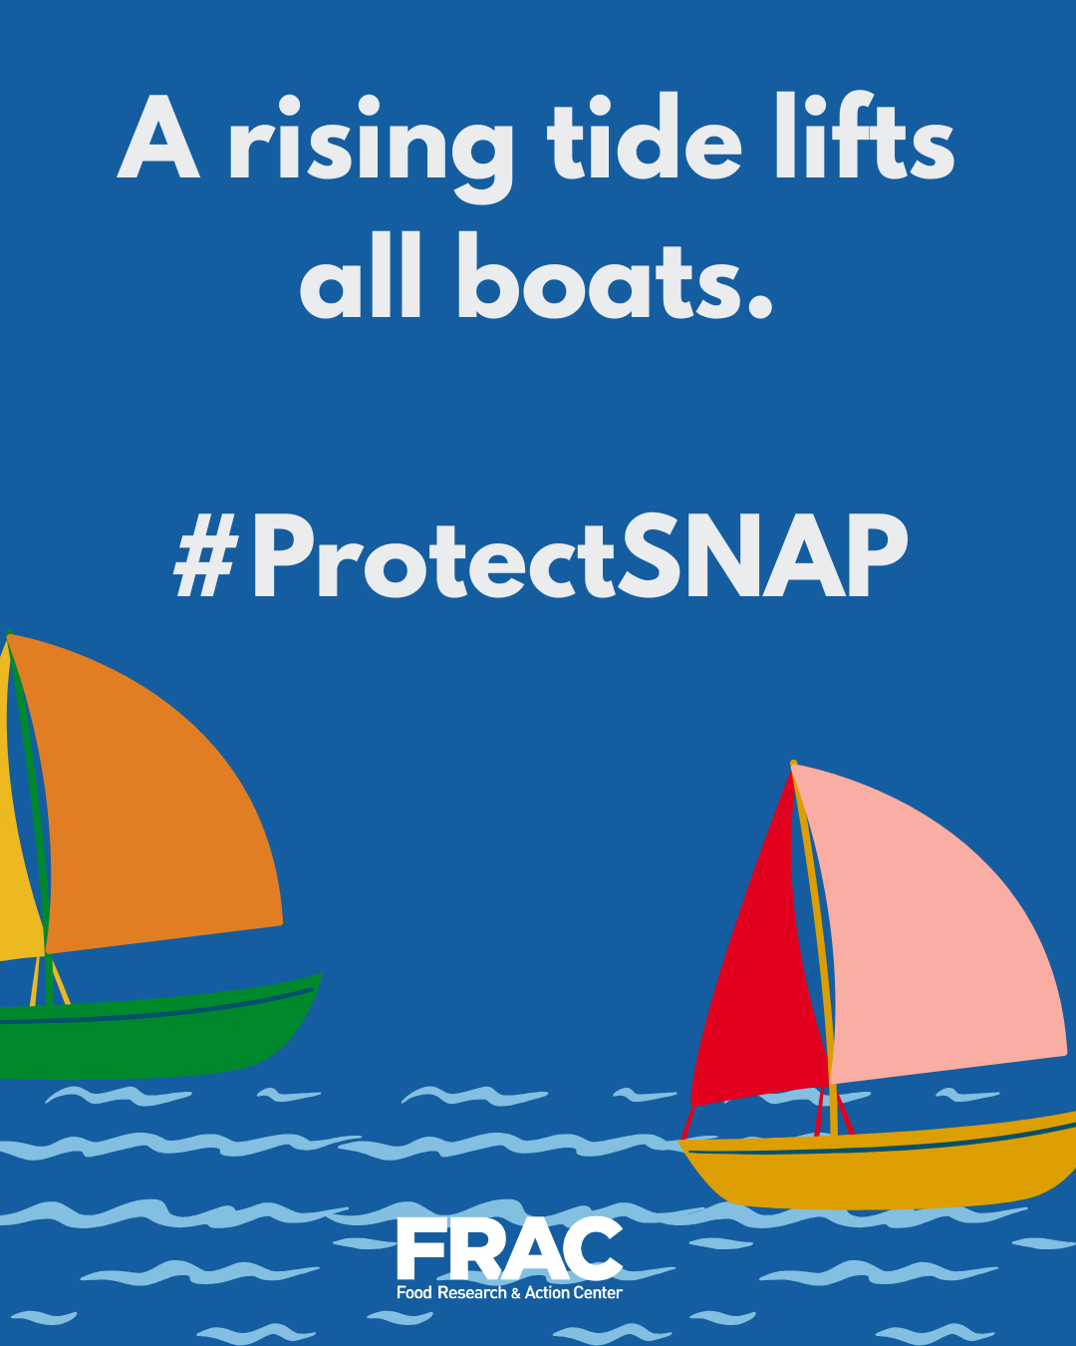
  - You can’t work, train, or learn when you’re hungry. Fighting hunger builds a stronger workforce. Tag and tell your Senators to #protectSNAP from any cuts. https://bit.ly/3RIejty
  - SNAP keeps millions afloat. Hunger sinks us all. Tell the Senate to #ProtectSNAP from any cuts. https://bit.ly/3RIejty
  - A strong SNAP program doesn’t just help individuals — it strengthens entire communities. Because when families have enough to eat, we all rise. #ProtectSNAP https://bit.ly/3RIejty

- 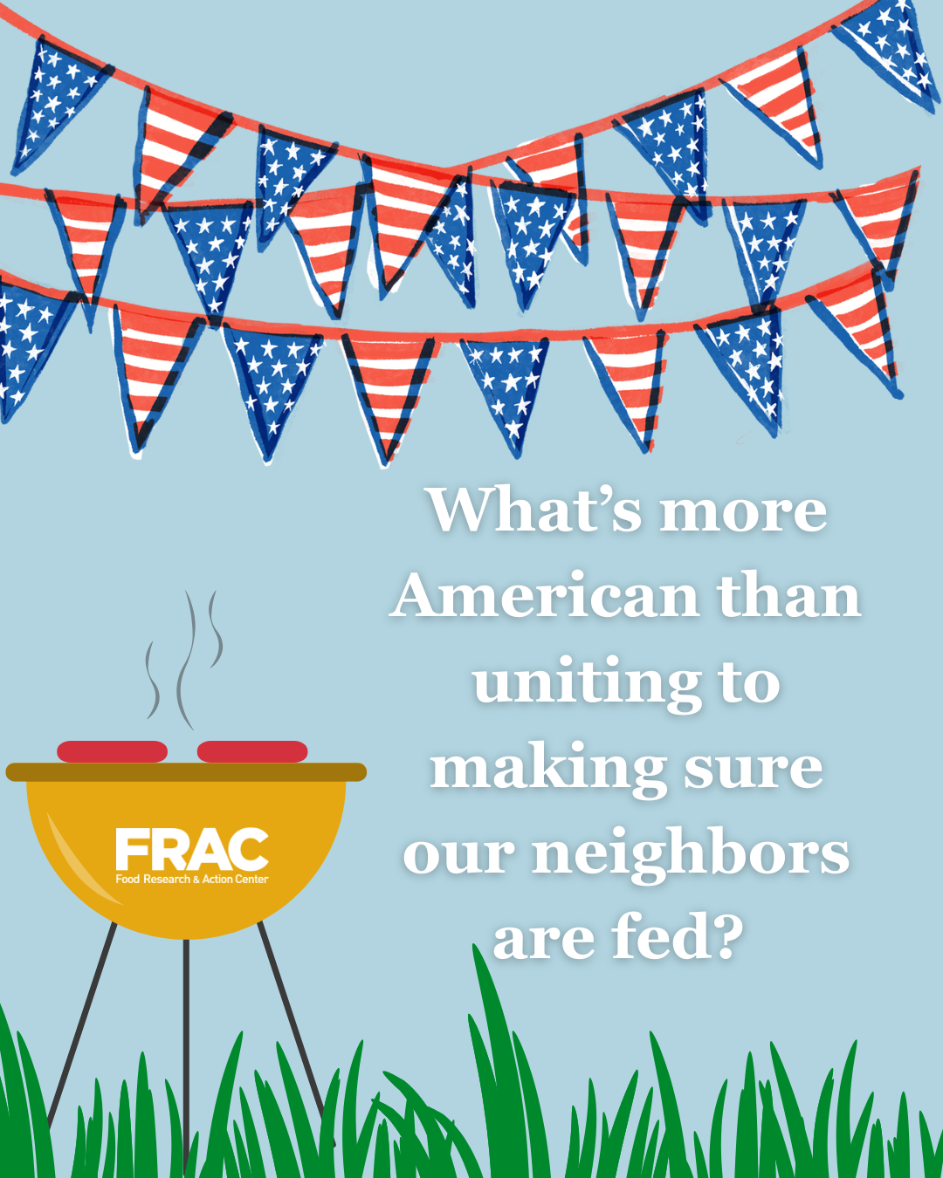
  - Summer BBQs, county fairs, fireworks—America is a community table. Support our neighbors who struggle to put food on the table. Tell the Senate to #protectSNAP. https://bit.ly/3RIejty
  - When people have access to food, they thrive. It’s really that simple. (Insert Senators handles), commit to building a nation free from hunger — starting with protecting SNAP. #SNAPmatters https://bit.ly/3RIejty
  - The only loud noises we should hear are fireworks in the sky, not the rumbling of empty stomachs. Tell Congress: NO SNAP CUTS #ProtectSNAP https://bit.ly/3RIejty
  - This 4th of July let’s stand for a country where no one goes hungry and no family skips dinner to make rent. Tell the Senate: NO SNAP CUTS. #SNAPmatters https://bit.ly/3RIejty
- 
  - Ending hunger is about more than food, it’s about building a country where children thrive, where they live, learn, and play. Households with children are the majority of SNAP households. Tell your senators to #protectSNAP, so children have the nutrition they need to thrive. https://bit.ly/3RIejty
  - America’s birthday wish? That every family has the nutrition they need to thrive. The Senate must #protectSNAP—no cuts, no exceptions. https://bit.ly/3RIejty
  - In honor of America’s birthday, let’s make a wish for a country where no child goes hungry and no family has to choose between groceries and rent. Tell the Senate: #protectSNAP. https://bit.ly/3RIejty
- 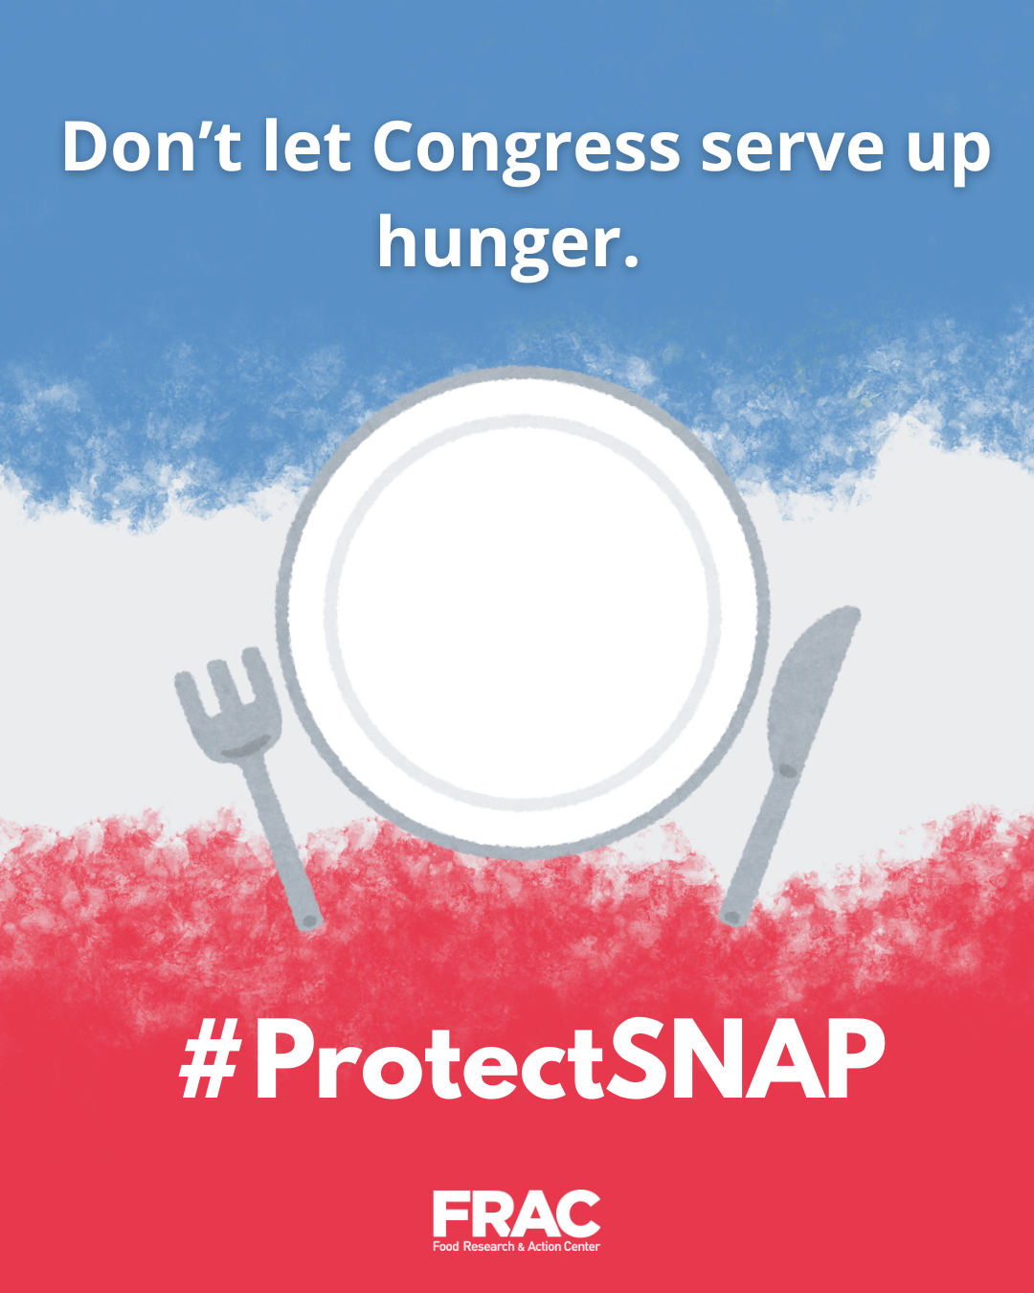
  - SNAP isn’t a handout—it’s a promise. That in this country, we don’t let our neighbors go hungry. The Senate must protect that promise. No cuts to food assistance. Period. #ProtectSNAP https://bit.ly/3RIejty
  - Every parent wants their child to have a full belly and a fair shot. We can build a nation free from hunger. Tell your senators to #ProtectSNAP. https://bit.ly/3RIejty
  - In the richest country on earth, hunger is not inevitable; it’s a policy choice. Tell your Senators to choose to end it: #ProtectSNAP https://bit.ly/3RIejty
  - We believe in a country where everyone can thrive—no matter their age, zip code, or income. That vision requires strong nutrition programs.
Cutting SNAP or school meals takes us backwards. #ProtectSNAP https://bit.ly/3RIejty

