**Get Vocal on Social: Oppose Cuts to SNAP to School Meals**

**Who**: You! Anti-Hunger Advocates

**What**: Share these posts across your social media platforms to activate your network

**Where**: BlueSky, X (formerly known as Twitter), Facebook, Instagram, LinkedIn

**Why**: To raise awareness and protect SNAP and school meals from any cuts

**Graphics**: Find and download graphics to include with your messages [here](https://bit.ly/41XAMre).

**Bonus Content:** Use these posts to share your state-specific data: <https://frac.org/wp-content/uploads/SNAP-Advocacy-Social-Messages.docx>

# No Cuts to SNAP/School Meals Sign on Letter

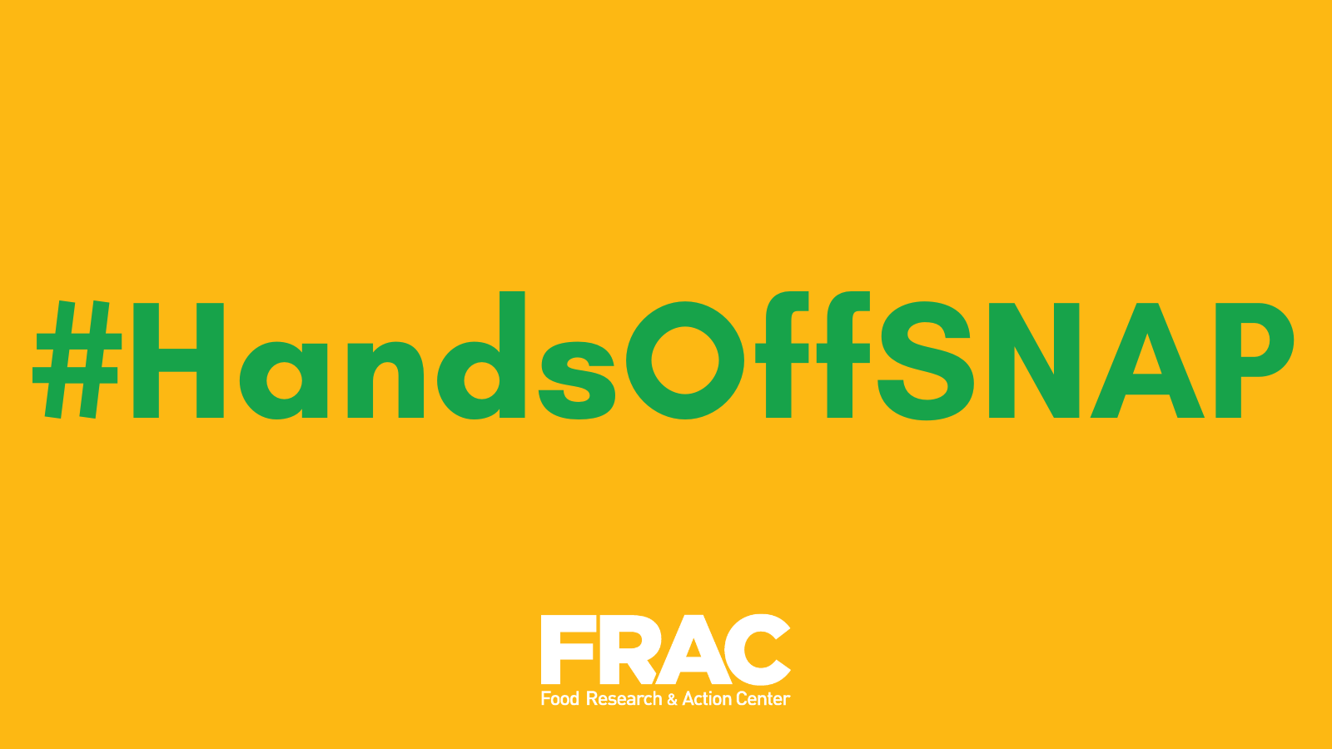

* Congress wants to slash billions from SNAP and school meals to fund tax breaks for the wealthy. Over 1,800 national, state and community organizations are speaking out: NO cuts to critical food and nutrition programs. SNAP keeps families fed, improves health, and strengthens local economies. Lawmakers must reject these cruel cuts. #HandsOffSNAP <https://bit.ly/4kv5Eri>

# Protect SNAP

### Story Collection

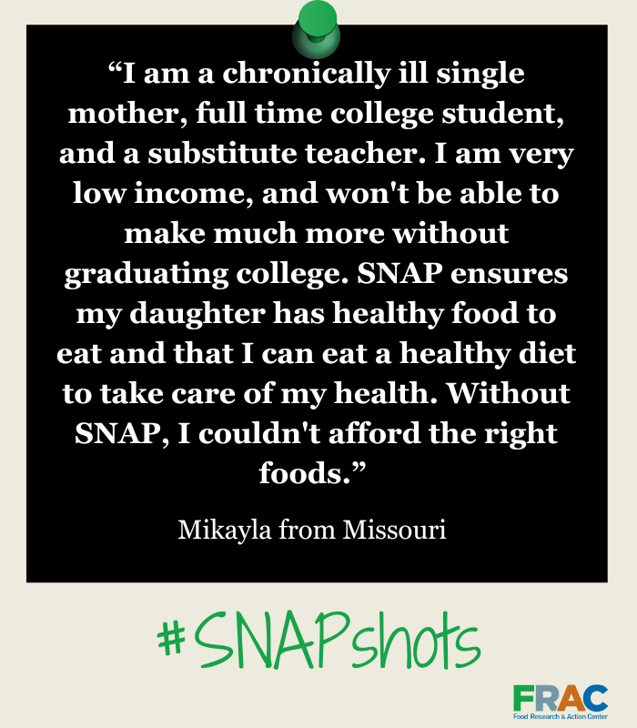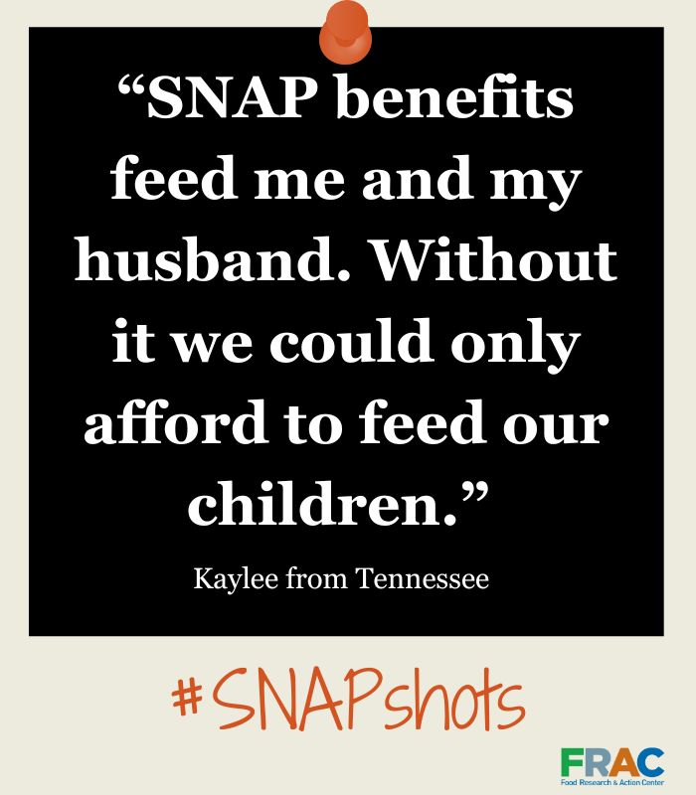

* SNAP helps individuals and families put food on the table. If you've relied on SNAP to get through tough times, your voice matters. Sharing your experience can help protect and strengthen these vital benefits. Tell us your story today. <https://bit.ly/4isIwb7> #SNAPMatters

### FRAC Action Network: Send a Message to Your Member of Congress

* 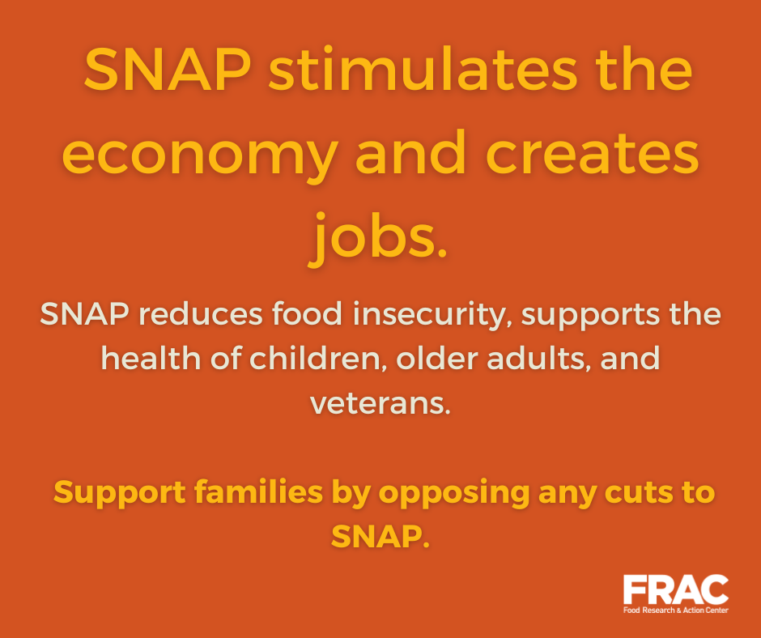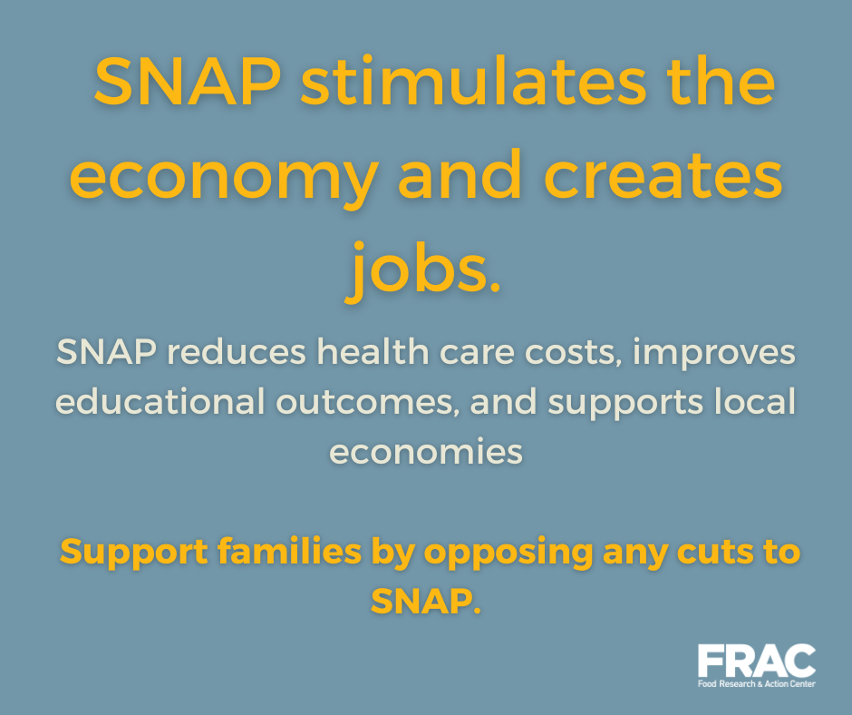Tens of millions of people rely on SNAP to put food on the table. Proposed cuts to SNAP would make it harder for kids, veterans, older adults, and people with disabilities to get the nutrition they need. Tell Congress: #HandsOffSNAP! <https://bit.ly/3Q833pn>
* From every corner of our country, #SNAPMatters. Speak up and tell Congress: #HandsOffSNAP! <https://bit.ly/3Q833pn>

# Protect School Meals

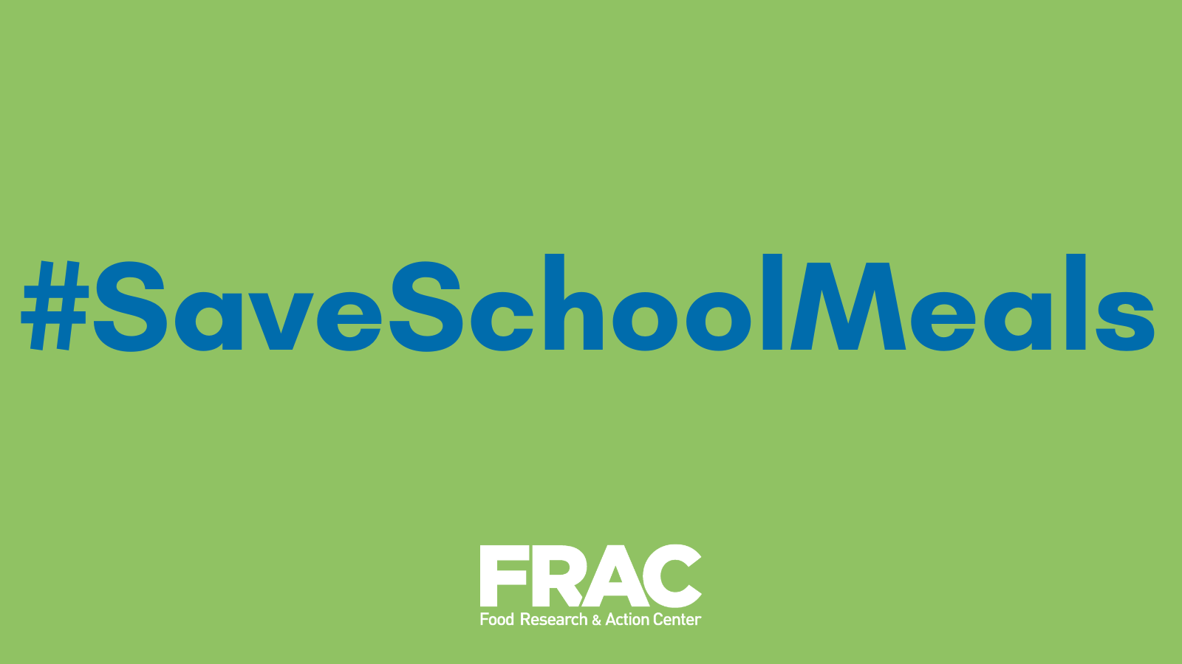

### CEP FRAC Chat

* Some in Congress are proposing cutting $12 BILLION from school meals—making it harder for 12 MILLION kids to get free breakfast and lunch. No child should go hungry at school. Congress should be expanding access to meals, not gutting it. <https://bit.ly/40oFWvm>
* Gutting school meal programs doesn’t just hurt kids—it burdens schools, increases paperwork, and brings back unpaid meal debt. The House Budget Resolution could slash $12 billion from school meals. We should be expanding access, not taking food away from children. <https://bit.ly/40oFWvm>

### FRAC Action Network

* Some in the House are coming after school meals—proposing $12 billion in cuts to school meals that would impact 12 million kids. This isn’t fiscal responsibility—it’s cruelty. Tell Congress: #SaveSchoolMeals. <https://bit.ly/3EYWTp4>
* Parents already have enough on their plates—now the GOP wants to make it harder for families to access school meals? Their plan would add unnecessary red tape & hurt kids applying for free and reduced-price school meals. Speak out now: <https://bit.ly/3EYWTp4>

### CEP Factsheets

* School meals should be easier to access, not harder. But some in Congress are considering cuts that would make it more difficult for millions of kids to get the nutrition they need. See how your state would be impacted in new fact sheets from @fractweets & @centeronbudget: <https://bit.ly/3DKc1q6>
* More than 23 million children rely on the Community Eligibility Provision (CEP) for free school meals—but some lawmakers want to gut the program. The latest fact sheets from @fractweets & @centeronbudget show how these cuts would increase childhood hunger and burden schools. Find out what’s at stake in your state: <https://bit.ly/3DKc1q6>