Sample National School Breakfast Week Social Media Posts

Leading up to NSBW:
- Twitter
  - Mark your calendars! Join us in celebrating #NSBW18 from March 5-9, because every student's day should start successfully.

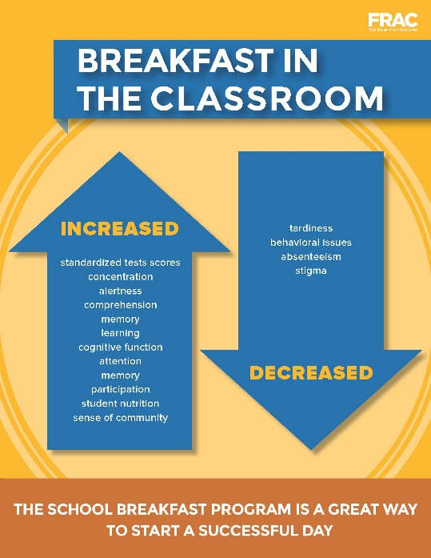

  - Improved nutrition? Check. Increased comprehension? Check. Here are all the reasons we're celebrating #NSBW18 on March 5-9. (insert infographic)
  - We're celebrating #NSBW18 on March 5-9. Read the research on #schoolbreakfast from @fractweets: http://bit.ly/2E5AZfJ
  - #NSBW18 is only # days away! Get ready with research from @fractweets on the national state of school breakfast: http://bit.ly/2E5AZfJ
- Facebook
  - Mark your calendars! Join us in celebrating National School Breakfast Week from March 5-9, because every student should start their day successfully. (insert infographic)
  - The benefits of school breakfast cannot be understated. Join us in celebrating the positive impact of the School Breakfast Program during National School Breakfast Week from March 5-9.
  - National School Breakfast Week is only # days away! Check out the most recent research from the @Food Research and Action Center on the benefits of school breakfast across the country – http://bit.ly/2E5AZfJ

During NSBW:
- Twitter
  - It’s #NSBW18! We’re celebrating improved dietary intake & educational outcomes, a great start to the day for millions of students.
  - Millions of students benefit from #schoolbreakfast. Learn more in @fractweets’ recent research: http://bit.ly/2E5AZfJ #NSBW18
  - School breakfast decreases tardiness & improves student participation - only a few of the countless reasons we’re celebrating #NSBW18!
  - Join us in sharing & celebrating the benefits of school breakfast for millions of students. #NSBW18 #EndHungerNow (insert infographic)
  - In INSERT STATE, ## students eat #schoolbreakfast for every 100 served #schoollunch: http://bit.ly/2E5AZfJ #NSBW18

- Facebook
  - It’s National School Breakfast Week! Read the research on protecting & strengthening the School Breakfast Program from the @Food Research and Action Center – http://bit.ly/2E5AZfJ
  - Increased test scores, decreased tardiness – we’re celebrating the benefits of school breakfast for National School Breakfast Week! Join us in promoting the positive impact of school breakfast on millions of students.
  - Do you know the state of school breakfast in the U.S.? Celebrate National School Breakfast Week with research from the @Food Research and Action Center – http://bit.ly/2E5AZfJ
  - In INSERT STATE, ## students eat school breakfast for every 100 served school lunch. Read the research in the new Breakfast Scorecard from the @Food Research and Action Center - http://bit.ly/2E5AZfJ

Why I Love #SchoolBreakfast

During National School Breakfast Week, in addition to the benefits of school breakfast, you can also share why you love school breakfast. For instance:
- Share photos of your favorite school breakfast
- Share why you love school breakfast and tag your family and friends
- Tweet @fractweets and why you love school breakfast
  - @fractweets Why I love #schoolbreakfast: Less hunger #NSBW18
  - @fractweets Why I love #schoolbreakfast: Ready to learn #NSBW18
- Tweet your Member of Congress your love for #schoolbreakfast. Find the handle of your representative here: https://twitter.com/gov/lists/us-senate/members?lang=en #NSBW18

# # #

