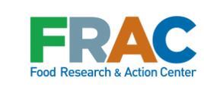

CHAMPIONS OF CHAMPS
Communications Toolkit

©September 2017

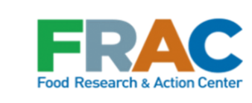

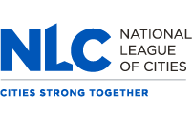

Cities Combating Hunger through Afterschool and Summer Meal Programs (CHAMPS)

The National League of Cities (NLC) and the Food Research & Action Center (FRAC) have been working closely with cities since 2012 to increase children’s access to healthy meals in out-of-school programs. CHAMPS works with city leaders and agencies to identify ways to grow participation in the federally funded afterschool and summer meal programs. With support from the Walmart Foundation, NLC and FRAC have provided grant funding and technical assistance to 71 cities and 18 anti-hunger organizations to help cities expand meal programs by establishing key partnerships, launching new meal programs, and expanding the capacity of program providers.

The meal programs are funded by the U.S. Department of Agriculture (USDA) through a state agency in each state, and meals provided under the programs are reimbursable based on federal guidelines.
Summer Nutrition Programs
There are two summer nutrition programs ─ the Summer Food Service Program (SFSP) and the the National School Lunch Program (NSLP) Seamless Summer Option. Children can eat for no charge at sites meeting the eligibility requirements for these programs. The Summer Nutrition Programs help combat hunger, which increases during the summer months. They also support summer programs that can help reduce summer learning loss, allowing children to return to school healthy and ready to learn.
Afterschool Nutrition Program
The Afterschool Meal Program provides funding to serve meals and snacks at no charge at sites offering educational enrichment activities afterschool, during weekends, and on school holidays. Serving a meal helps draw children and teens into programming that keeps them safe, engaged, and out of trouble while their parents are working. Participants have been found to have a higher daily intake of key nutrients and vitamins on days they eat afterschool meals compared to days they do not.

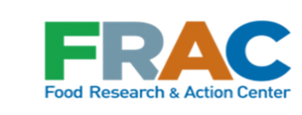

Table of Contents

Celebrating the Afterschool Meal Program…………………………………………………………………4

Model Talking Points…………………………………………………………………………….………………………5

Goals of CHAMPS………………………..………………………………………………………………………….…….6

Model News Release…………………………………………………………………………………………….….......8

Sample Social Media Posts……………………………………………………………………………………………9

Infographics…………………………………………………………………………………………………………………10

Sample Mayoral Proclamation……………………………………………………………………………………14

Celebrating the Afterschool Meal Program

Congratulations! As a grantee of the Cities Combating Hunger through Afterschool and Summer Meal Programs (CHAMPS), you have given more children access to healthy meals when school is out of session.
Since 2012, city leaders, agencies, and anti-hunger advocates in 71 cities participating in CHAMPS have played a crucial role in generating awareness about the importance of the afterschool and summer nutrition programs. This has been a critical effort since oftentimes families are not aware of afterschool or summer meal sites, or they may not realize that their children are eligible to participate.
In addition to launching new meal sites, CHAMPS cities have created streamlined and comprehensive marketing campaigns to raise awareness within their communities of meal programs generally, and of site locations specifically. Outreach and awareness campaigns have increased the visibility of the meal programs, boosted participation at sites and improved the overall nutrition and health of children across the community.
Because of you, the goals of CHAMPS are being met:
- Increased participation in afterschool and summer meal programs;
- Improved seamless implementation of year-round out-of-school time meals; and
- Increased engagement of city agencies and elected officials.
Yet, we know this is just the beginning. Too many children are still missing out on these important programs.
The National League of Cites (NLC) and the Food Research & Action Center (FRAC) have created this toolkit to help city leaders and agencies like yours share your successes to further grow participation in the federally funded afterschool and summer meal programs and to inspire others to do the same. On the following pages, you will find:

  - press release to promote your work around CHAMPS
  - talking points for your city leaders to speak about CHAMPS
  - infographics for current grantee states and CHAMPS alumni
  - sample mayoral proclamation
NLC and FRAC are grateful for the support of the Walmart Foundation, which has made grant funding and technical assistance for CHAMPS possible.

Please visit NLC.org or FRAC.org for additional information.
Mark Your Calendar for Wednesday, October 18, at 3:00 pm. Eastern, NLC and FRAC will host a Twitter chat to shine a spotlight on you as one of the Champions of CHAMPS. Please join us in this celebration and rallying call for the importance of afterschool and summer meals across the nation.

Model Talking Points
CACFP Afterschool Meals
- The Afterschool Meal Program provides nutritious meals, combating childhood hunger in our community, while providing enrichment activities in a safe and supervised environment.
- Offering afterschool meals draws children and teens into educational and enrichment programming after school and keeps them engaged when the school day ends.
- Federal funding covers the cost of the meals and snacks for children up to age 18 when your afterschool program participates in the Afterschool Meal Program, which is offered through the Child and Adult Care Food Program (CACFP).
- Afterschool Meal Program sites can be located in schools, recreation centers, YMCAs, Boys and Girls Clubs, and in other locations where afterschool programs are offered to children. To qualify, they must be located in low-income communities.
- The CACFP Afterschool Meal Program can operate after school, on weekends, and during school holidays or breaks during the school year.
- The city is proud to announce that children and teens can now receive afterschool meals at sites at (fill in location, times, activities available).
CHAMPS: Cities Combating Hunger through Afterschool and Summer Meals Programs
- CHAMPS is a project of the National League of Cities (NLC) and the Food Research & Action Center (FRAC). Supported by the Walmart Foundation, NLC and FRAC provide grant funding and technical assistance to cities to increase participation in the summer and afterschool meal programs.
- As a CHAMPS city this year, we are working closely with (the Alabama Food Bank Association/California Summer Meal Coalition/Kansas Appleseed) to increase the number of children in our city who receive healthy meals after school and during the summer. We are expanding the capacity of meal program providers and spreading the word to families that these meals are available to their children.
- As mayor, it is important to me that our city’s children have the nutrition they need to grow up healthy, happy, and be able to succeed. I thank all the partners working together on our CHAMPS initiative to increase access to these vital programs in our community.
- Through our work on CHAMPS, the city has developed and strengthened relationships with (fill in partners) to serve more nutritious meals to our children when they are out of school — after school or during the summer.
- Afterschool meals are offered at (fill in locations and days). If you are interested in becoming an Afterschool Meal Program site or sponsor, contact (fill in name) to find out more information.

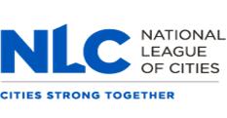
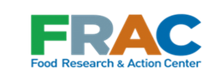

Goals of CHAMPS

Increased participation in summer and afterschool meal programs
Millions of children rely on free and reduced-price school meals during the school year, and when the school day or year ends, many of these children go hungry. In July 2016, the federal Summer Food Service Program reached only 1 in 7 of the children receiving free or reduced-price school lunch during the preceding school year. As a relatively newer federal program, the Afterschool Meal Program reaches even fewer children. CHAMPS helps cities increase the capacity of providers and supports their marketing and outreach efforts to increase awareness of, and participation in both programs.

Improved seamless implementation of year-round out-of-school time meals
CHAMPS encourages cities to coordinate a year-round focus on both summer and afterschool meal programs as this coordination can lead to increased awareness, capacity, and sustainability. A year-round focus increases visibility of meal sites in the community, increases staff retention in programs, and allows sponsors to develop stronger relationships with state agencies.

Increased engagement of city agencies and elected officials
City leaders have an important role to play to ensure that children in their communities have access to nutritious meals and quality enrichment programs when they are out of school. CHAMPS encourages city leaders to use their bully pulpits to reduce the number of families struggling against hunger by promoting the availability of meal programs in their community. Cities also are encouraged to sponsor meal programs, making meals available at city locations like community centers, parks, and libraries.

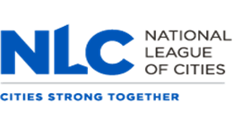
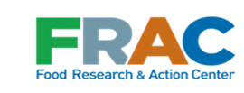

CHAMPS 2016-2017 Cohort: Alabama, California, and Kansas

To build momentum and increase awareness statewide about the summer and afterschool meal programs, the current CHAMPS cohort includes cities exclusively in three states: Alabama, California, and Kansas. In addition to funding 31 cities in the three states, CHAMPS is providing funding to a local statewide anti-hunger organization in each state to provide technical assistance and guidance to CHAMPS cities through December 2017.

CHAMPS cities receive one-on-one guidance, resources and connection to national best practices, and the opportunity to hear from and share with peers through newsletters and cohort webinars that connect grantee cities to each other.
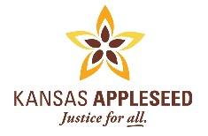

Model News Release
City Offers More Afterschool Meals to Young People
CITY, STATE, DATE — More children in City are participating in afterschool meal programs as a result of CHAMPS, or Cities Combating Hunger through Afterschool and Summer Meal Programs. City is one of 31 cities across the country currently receiving funding and technical assistance from the National League of Cities and the Food Research & Action Center to ensure low-income children have access to healthy food and enrichment activities after school, on the weekends, and during school holidays.
“Too many children in City face a hunger gap between school lunch and the next school day’s breakfast,” said local official/advocate, title, organization. “The Afterschool Meal Program provides nutritious meals alongside enrichment activities in a safe and supervised environment, and helps combat childhood hunger in our community. We are proud to be investing in our young people through CHAMPS.”
City is working closely with (insert partner: the Alabama Food Bank Association/California Summer Meal Coalition/Kansas Appleseed) to increase the number of children receiving healthy meals after school by expanding the capacity of meal program providers and spreading the word to children and families about the availability of these meals.
There are currently # afterschool meal sites across the city, including list sponsors/sites and note how many have begun as a result of CHAMPS. Include brief description of sites, e.g., how many kids estimated to be served, type of enrichment activities, how the children feel about the program].
“It is important that our city’s children have the nutrition they need to grow up healthy, happy, and prepared to succeed,” added last name of local official/advocate quoted above. “I thank all the partners working together on CHAMPS to increase access to this vital program in our community.”
###
CHAMPS is a project of the National League of Cities (NLC) and the Food Research & Action Center (FRAC). Supported by the Walmart Foundation, NLC and FRAC provide grant funding and technical assistance to cities to increase participation in the Afterschool and Summer Meal Programs.

Sample Social Media Posts
Use the sample social media posts below and graphics on the following pages to boost awareness about what your city has done to expand the Afterschool Meal Program through CHAMPS. Encourage other cities to build on your momentum.
Follow @fractweets and @leagueofcities

Twitter:
- The Afterschool Meal Program supports tutoring and recreational activities, learn more http://bit.ly/2f5Al6W
- Did you know your child has access to free afterschool meals and mentoring right here in [name of city]? (Link to your resources/website)
- [Insert City Name] provides meals for students when school's out. Learn more about our programs: (Link to your resources/website)
- [Insert City Name] is proud to provide nutritious meals when school is out through the Afterschool Meals Program: http://bit.ly/2f5Al6W
- [Insert City Name] is doing it, & so can your city! 10 steps for ensuring kids get healthy meals when school's out: http://bit.ly/2xKXDdM
- [Insert City Name] is ending childhood hunger through afterschool meals! Check out @leagueofcities CHAMPS guide: http://bit.ly/2xKXDdM
- We're fighting childhood hunger in [Insert City Name] w/@leagueofcities & @fractweets! Learn more: http://bit.ly/2xKXDdM
- [Insert City Name] leaders are fighting hunger through CHAMPS → afterschool meals for all students: http://bit.ly/2ykNXnx
- [Insert City Name] is proud to be one of 71 CHAMPS cities across the country working to provide afterschool meals → http://bit.ly/2ykNXnx

Facebook:
[Insert City Name] is proud to fight childhood hunger through CHAMPS afterschool meals: http://bit.ly/2ykNXnx

Mark your calendar for Wednesday, October 18, at 3:00 pm. Eastern for the Champions of CHAMPS Twitter chat, hosted by NLC and FRAC.

Infographics
Cities Participating in CHAMPS

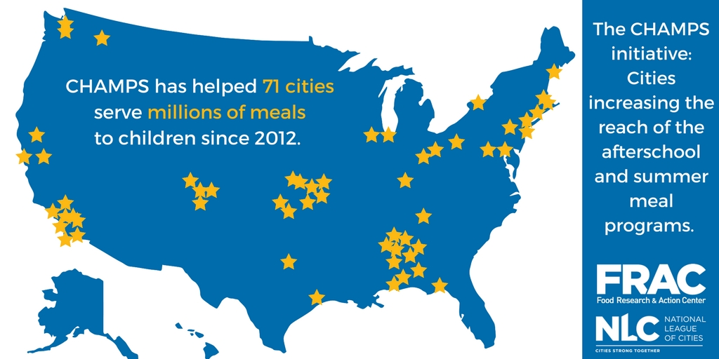

Download this infographic

Alabama:
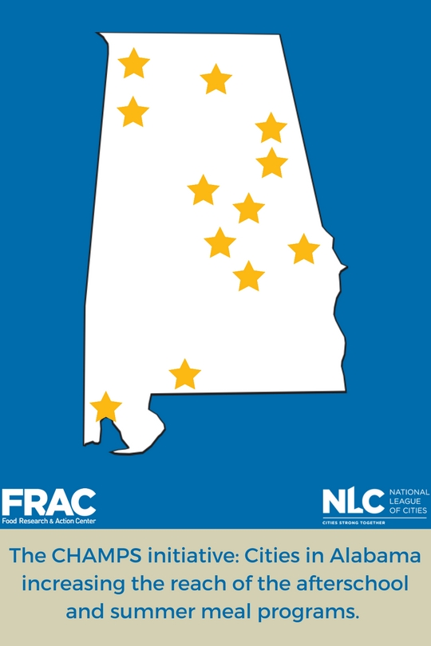
Download this infographic
California:
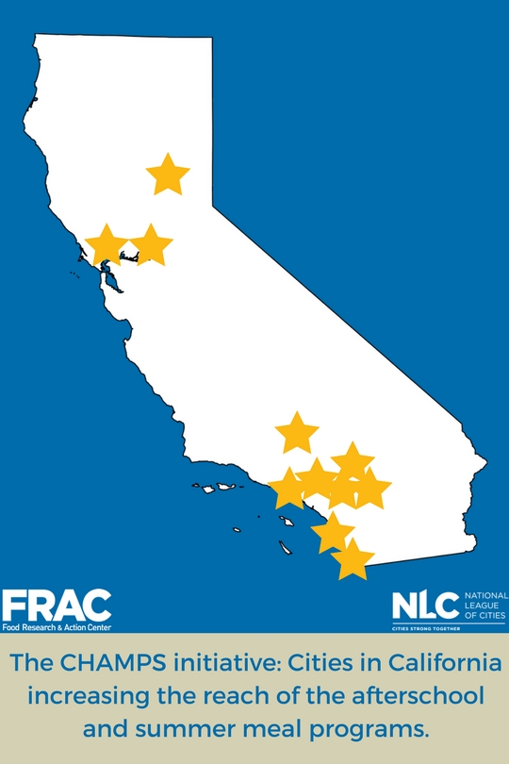
Download this infographic
Kansas:
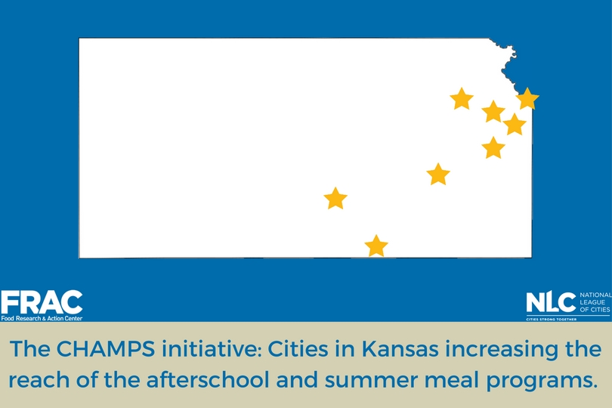
Download this infographic

Sample Mayoral Proclamation

Healthy Afterschool Meals for Students: A Proclamation
WHEREAS, Afterschool programs should be about keeping students safe, inspiring them to learn, and supporting working families; and

WHEREAS, When the school bell rings, students who rely on school meals might not otherwise have access to all the nutrition they need to be active and healthy; and

WHEREAS, 1 in # Alabama/California/Kansas children faces food insecurity, and meals provided through the Afterschool Meal Program provide an important source of good nutrition; and

WHEREAS, Afterschool Meal Program sites also provide CITY NAME children with a place to spend time with friends, learn, and stay active when the school day ends; and

WHEREAS, Afterschool meals can help children stay healthy and prepare them to return to school the next day ready to learn and thrive; and

WHEREAS, By increasing participation in the Afterschool Meal Program through community outreach, adding new meal sites, and investing in afterschool programming to attract more kids to meal sites, cities can increase access to healthy meals; and

WHEREAS, CITY NAME is committed to making sure no child goes hungry year-round;

NOW, THEREFORE, I NAME, Mayor, do hereby proclaim CITY NAME is a City Combatting Hunger through the Afterschool and Summer Meal Programs and October #, 2017, as "Healthy Afterschool Meals for Kids Day."

In witness whereof, I have hereunto set my hand on this.

____________________________________
Name, Mayor

____________________________________

About National League of Cities (NLC)
The National League of Cities is a resource and advocate for the nation's cities and their leaders. Learn more at NLC.org.

About the Food Research & Action Center (FRAC)
The Food Research & Action Center is the leading national nonprofit organization working to eradicate poverty-related hunger and undernutrition in the United States. Learn more at FRAC.org.

If you’re interested in sharing your experiences about CHAMPS with other cities to help expand afterschool meals, please contact Dawn Schluckebier, 202-626-3040, schluckebier@nlc.org.

